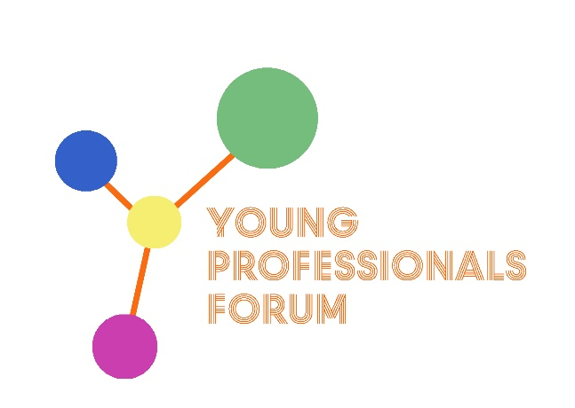

TITLE
[in Calibri 14 capitals]

First Author*, Second Author**, Third Author***
(in Calibri 11 bold)

*Affiliation, Affiliation address, e-mail of the author [in Calibri 11]
** Affiliation, Affiliation address, e-mail of the author [in Calibri 11]
*** Affiliation, Affiliation address, e-mail of the author [in Calibri 11]

Session: [Specify the theme session: Conservation ethics and practice, Diagnostics and technologies applied to conservation, Museum professions or History of conservation – in Calibri 11 bold]

Text [Each abstract must be prepared in this format. The abstract must include title, Name(s) and Surname(s) of author(s), affiliation(s), email, text (and figures). Language: English. Length: preferred 500, maximum 700 words. Paper Format: A4 Portrait (297 x 210 mm), 1.91 cm margins on the left and right, 2.54 on the top and bottom. Font: Calibri 11, single-spacing. File format: MSWord (.doc or .docx). The abstract should be in text form with tables and maximum 4 figures (if required) included in the text. Please underline the author who will present the paper.
Each paragraph should be intended by 0,5 cm and separated from the previous by 4pt.]

